UnWork Newsletter

Return to the Office – why ‘Hot Desking’ is the way forward
a different approach to get people back into a safe workplace

The Government is wrong. ‘Hot desking’ is a good solution to get people back to work. It lets the right number of people use the office each day so that they are spread out and it also allows the space to be cleaned effectively after each use to reduce contamination of work surfaces and technology. Desks need to be sterilised every night to stay safe. It also provides a way for companies to reduce costs and UnWork predicts that up to 60% less office space will be needed through a combination of shared space and home working.

‘Hot desking’ is taken from the Royal Navy where hot bunking is a solution in restricted space. When desks aren’t being used, why heat or cool and light the space. And now with Covid considerations ‘hot desks’ are great desks because in between use or overnight the desks are left empty and clear and so they can be effectively cleaned and sterilised. If people have their own desks, they are normally cluttered and can’t be cleaned. Moreover, co-workers who normally sit together can’t come in on the same day so it will become a logistical nightmare to work out when people can come in if they sit at their own desks.

Before Covid-19 shut down the workplace, companies were already reporting that only 47% of desks were used on an average day. With companies desperate to reduce costs, we predict that a 60% reduction of office space is now a realistic proposition in the post-Covid workplace. UnWork, the future work specialists, predicts a reduction of £10,000 per person per year in workplace costs by providing far fewer, shared desks and some of these savings should be reinvested in home working so people have the right furniture and technology solutions.
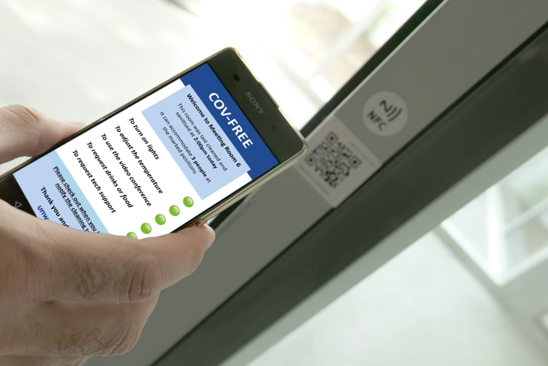
To achieve Return to the Office there will need to be a COV-free App that lets people know when they should come in with times allocated to prevent congestion in lobbies or lifts (elevators). People get assigned a desk (that an algorithm has allocated achieving 2-metre distancing), they ‘check in’ by touching their own mobile (cell) phone on a tag or scanning a code that tells the facilities team that the desk is being used and lets health and safety monitor who is sitting where. The App also lets the person see when the desk was last cleaned and lets them order food and drink that can be delivered to them or a nearby drop off.

Then when they leave their desk they scan again to ‘check out’ which alerts the cleaning team to sanitise the desk and change any technology peripherals such as keyboards and mice. In this way a healthy workplace can be achieved that is virus free. Based on the number of people sitting on a floor, air conditioning can be adjusted to increase fresh air flow.

And if a co-worker does test positive for Covid-19 a few days after being in the workplace, the Cov-Free App can alert people who were working close by, allowing employers to provide a responsible and healthy workplace.

This approach is important. With the required distancing, there is a 57% reduction in capacity of the workplace to achieve 2 metre separation between desks. We have illustrated a typical workplace with a capacity for 240 people and the re-plan to accommodate distancing where only 43% of space can be used.

Where next? – the Office of the Future

But we will now question why we need to go to the workplace at all? If we are just sitting at isolated desks, people might as well continue to work from home. With portable technology, the cloud and software provided as a service the office as a container for work is redundant. So, the office needs to provide more.

People will only go back to workplaces to interact with others. But where does this take place? Meetings will need to happen on, or near, the ground floor to avoid lifts and bottlenecks and the complexity of bringing visitors into the office. Companies should turn reception areas into meeting spaces and a café. New spaces for meetings should be created in the open to avoid people sitting in enclosed meeting rooms.

Next will be a demand for smart buildings. UnWork has advised Lipton Rogers, developers of 22 Bishopsgate, which will be London’s smartest building when it opens next year. People will enter the building with ‘facial biometrics’ with lifts called automatically. A smart App allows integration with building services such as air conditioning as well as shared services from food and drink to medical care.

With Covid-19 we will now need smart buildings to allow the ‘touchless office’ so that our face handles security and our mobile phone acts as a universal ‘remote control’. With greater use of voice and gesture to control and activate, work and communicate the office of the future will be dramatically different.

Ends

Impact of separation in a typical workplace
2
1
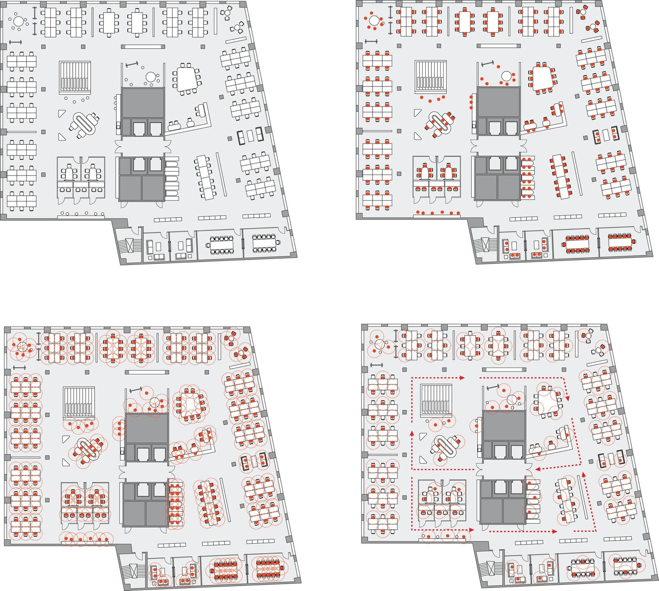
4
3

- Typical floorplan of an office
- Red dots show people and their normal work positions – 240 people
- 2 metre distances between people showing conflicts
- Covid-19 enabled workplace with separation – capacity falls to 104 so a 57% reduction

Our concept for a COV-Free Workplace App
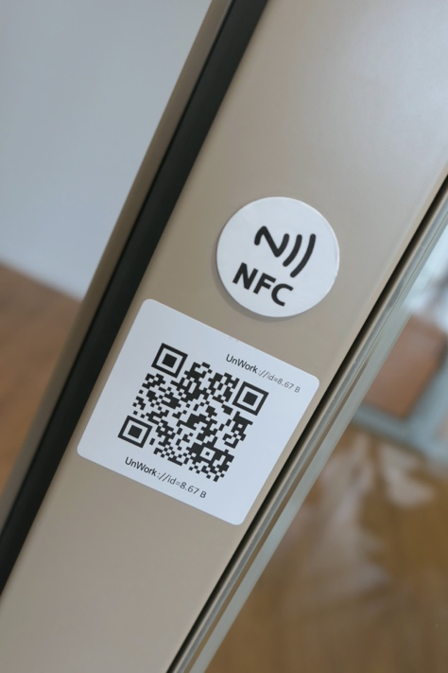
6

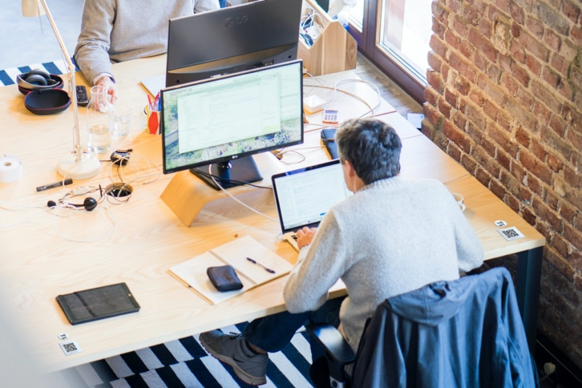
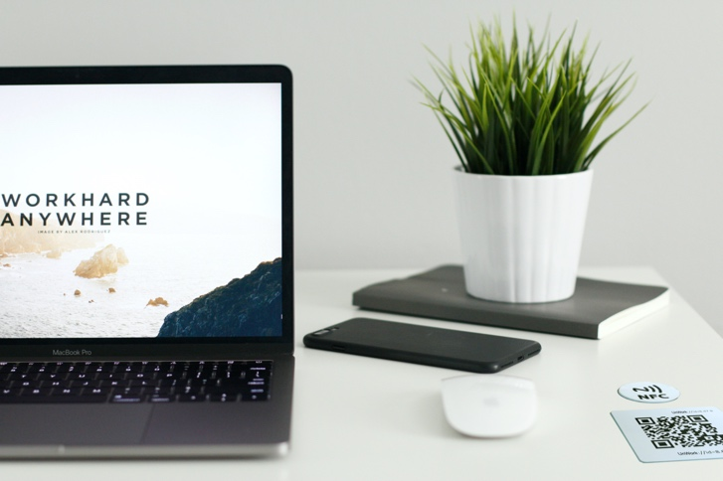
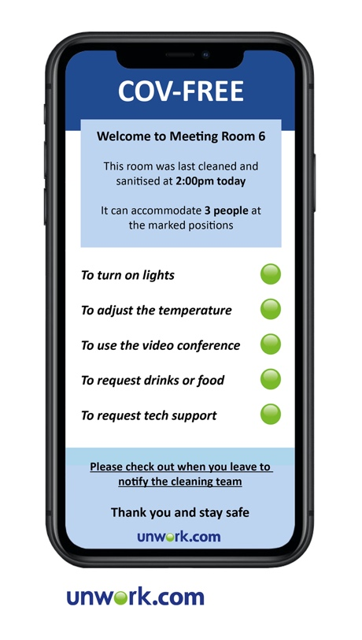
- People check into a meeting room or desk using their phone
- Either a radio frequency tag using NfC or a pdf bar code are applied to the door frames of all rooms and private offices
- All desks also have a unique NfC tag or bar code
- The Cov-Free App has been developed by UnWork Labs. Once people check in, it tells them when the space was last cleaned and in smart buildings lets people use their mobile phone as a ‘remote control’.

It also allows monitoring of where people can sit and if someone later tests positive for Covid shows who was nearby

8
7
5

